
17th annual International Technology, Education
https://iated.org/inted/

THEME: -- https://iated.org/inted/topics

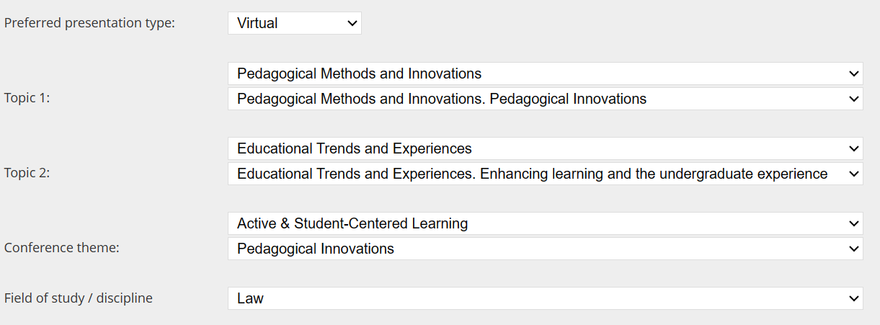

TITLE:
IMPLEMENTATION OF ACTIVE PEDAGOGICAL PRACTICES
IN TEACHING CONSTITUTIONAL LAW TOWARDS DEMOCRACY

AUTHORS: Dora Resende Alves, PhD dra@upt.pt
Daniela Castilhos, PhD daniela.castilhos@ipleiria.pt

INSTITUTIONS:
Universidade Portucalense Infante D. Henrique, Departamento de Direito,
Rua António Bernardino de Almeida, Porto, Portugal, +351225572609.

Instituto Politécnico de Leiria, Escola Superior de Tecnologia e Gestão,
Morro do Lena – Alto do Vieiro, Leiria, Portugal, +351 244820310

ABSTRACT: 3500 characters including spaces 2911

The present study aims to define and report on the implementation of new pedagogical practices in the curricular unit of Constitutional Law with the aim of promoting student-centered teaching. The pedagogical practices adopted were designed to foster an active and participatory learning environment. Additionally, they were chosen while taking into account the “gamification” strategy using elements of games outside the sphere of gaming which can be applied as a teaching strategy. In undergraduate studies, the application of the active learning strategy in the classroom presents a significant challenge for education in its traditional sense. Specifically in the case of studying law, the following techniques were used: oral test simulation, written test simulation with peer assessment, “cube with review questions”, and walking gallery.

The choice of Constitutional Law as the curricular unit for this study was not random. Constitutional Law is a paradigmatic subject in the training of a lawyer and, normally, appears in the first year of a law degree because it provides a structural understanding for the student. Additionally, it contains concepts inherent to citizens, including young students. The concept of the State, the acquisition of citizenship, the understanding of sovereign bodies, the understanding of the separation of powers, the awareness of the functions of the State and even the inherent idea of the Rule of Law, an idea ingrained in the mindset of young law school students. Through dynamic learning methods, ideas that are already part of a student as a young citizen are highlighted.

With this study, we have sought to understand the students' perception of these active pedagogical practices. We have and will continue to analyze student responses to identify their views, opinions and experiences regarding this new teaching method. These insights will be assessed both quantitatively and qualitatively to gain a comprehensive understanding of the impact of the implemented practices.

The perception and interests of students have thus far have been positive. These initial results point to the effectiveness of the strategies adopted, although we recognize the continuous need for improvements and adjustments, in order to fully meet the students' expectations and needs. As such, we acknowledge that this technique presents some limitations. That being said, however, it is expected that the study will reveal a natural predisposition to active methodologies. The students in this curricular unit in general, demonstrate a natural and innate ease in understanding the concepts of Constitutional Law. Since these are students who have chosen to study a law degree, it is believed they will have greater speed in translating and highlighting ideas of citizenship via these dynamic methods, already typical of their capacity as members of a democratic State under the rule of law towards Democracy.

Keywords: gamification; gallery walk; active learning; Constitucional Law.

Referências breves
Barata, M. S., & Alves, D. R. (2023). O ensino do Direito Constitucional: Uma nova metodologia assente na cidadania e democracia [abstract]. In E. Esteves, D. Estêvão, J. Monteiro, M. Correia, & S. Fernandes (Eds.), CNaPPES 2023: 9.º Congresso Nacional de Práticas Pedagógicas no Ensino Superior: Livro de Resumos, Faro, Portugal, 6-7 julho 2023, (pp. 112-113). Universidade do Algarve. Repositório Institucional UPT. http://hdl.handle.net/11328/4965

Castilhos, D. S., & Alves, D. R. (2019). A inovação docente na prática pedagógica: estudo de caso de gamificação no ensino do direito. In R. M. Gonçalves, & F. S. Veiga (dirs.); P. Brito (Coord.), Estudios de Derecho Iberoamericano (vol. 3, pp. 557-564). Porto: Universidade Lusófona do Porto. Disponível no Repositório UPT, http://hdl.handle.net/11328/2859

Castilhos, D. S. (2018). Gamification and active methodologies at university: The case of teaching learning strategy in law. In ICERI2018 Proceedings of 11th International Conference of Education, Research and Innovation (pp. 5208-5211), Seville, Spain, 12th-14th Nov.2018. doi: 10.21125/iceri.2018.0220. Disponível no Repositório UPT, http://hdl.handle.net/11328/2604

Miranda, J. (2022). A Constituição Portuguesa - Uma Introdução Geral. Almedina.

Silva, M. M. M., & Alves, D. R. (2022). Noções de Direito Constitucional e de Ciência Política (4th ed.). Rei dos Livros.

Documentação

Parlamento Europeu. (2021). Resolução do Parlamento Europeu, de 22 de outubro de 2020, de 11 de novembro de 2021, sobre o Espaço Europeu da Educação: uma abordagem holística conjunta. In Jornal Oficial da União Europeia: Vol. C (Issue 205, pp. 17–25). Serviço das Publicações da União Europeia. https://eur-lex.europa.eu/legal-content/AUTO/?uri=CELEX:52021IP0452&qid=1665949064080&rid=8

Comissão Europeia. (2022). Comunicação da Comissão ao Parlamento Europeu, ao Conselho, ao Comité Económico e Social Europeu e ao Comité das Regiões Concretizar o Espaço Europeu da Educação até 2025. Documento COM(2020) 625 final de 30.09.2020. Serviço das Publicações da União Europeia. https://eur-lex.europa.eu/legal-content/PT/TXT/PDF/?uri=CELEX:52020DC0625

Conclusões do Conselho sobre o contributo da educação e da formação para o reforço dos valores europeus comuns e da cidadania democrática
JO C, C/2023/1339, 29.11.2023,
ELI: http://data.europa.eu/eli/C/2023/1339/oj

- Abstract Submission Deadline: EXTENDED: December 7th, 2023. (included)
- Notification of Acceptance/Rejection: December 20th, 2023.
- Final Paper Submission Deadline: January 11th, 2024. (included)
- Registration deadline for authors: January 11th, 2024. (included)
- Virtual presentation deadline: February 8th, 2024. (included)
- Conference Dates: Valencia (Spain), March 4th-5th-6th, 2024.

