13th annual International Conference on Education and New Learning Technologies

EDULEARN21

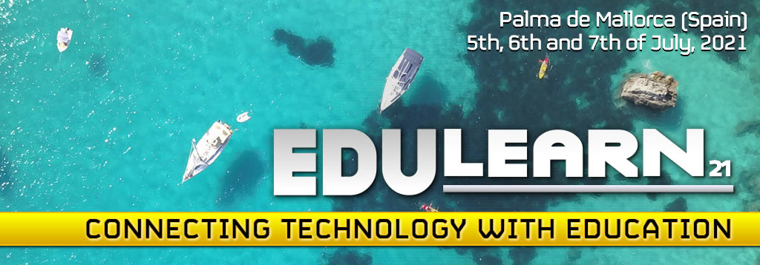

5-6 JULY, 2021
PALMA, SPAIN

IATED Conferences
Títle
Education for access to European Union law through the use of digital technologies

Theme: European Union Law

AUTHORS:

Maria Manuela Magalhães Silva, Universidade Portucalense Infante D. Henrique, Porto, Portugal

Dora Resende Alves, Universidade Portucalense Infante D. Henrique, Porto, Portugal

ABSTRACT:

The integration model followed in the construction of the European Union (EU) considers the action of institutions, which develop competences and lines of work through legislative, decision-making and sanctioning paths. All procedures involved result in the documents. Public documents through publication in the official journal or in the official sites; available, as a source of law, on the internet address or in the EU's own publications, whitch access may be available to specialists or to the public, being in the interest of citizens, academics or bodies. Therefore, different access levels are created. The European Union is a union of common values and is based on the values of democracy, human rights defense and the rule of law, so, with a strong component of creation and respect for legal rules.
The chosen theme concerns the effective application of EU rules as an important aspect for European citizens that affects their daily lives and how citizens feel the proximity to EU law. The problem is not always the absence of EU legislation, but the fact that it can be known and applied effectively. Education about the EU is a challenge that requires a greater emphasis on execution in order to serve the general interest. And what role does the use of digital technologies play in this context? How can the use of these technologies bring citizens closer to the functioning of the EU? Will there be a strengthening of democracy on this path? How can auxiliary education policy? Those are the questions to be answered.
The purpose of this analysis is to demonstrate that, as Member States are primarily responsible for the application of EU law, there is still an effort to be made for the efficiency of European law enforcement procedures through the use of new technologies. And that without the support of education, it becomes difficult.
Considering the embryonic nature of this study, a methodology was designed that focus on the use of European Union law sources, through systematic and methodologically selected normative interpretation. It focuses on specialized publications but above all official documents (legislative or preparatory) that set out the issue. The theoretical-academic tendency is consolidated through systematic normative interpretation and aims to expand knowledge, in a qualitative and exploratory approach. Without presenting quantitative data, the purpose is to bring to discussion and debate the role, value and capacity of using new technologies and education for the dissemination and application of European Union law. In this way, the expected results will be a deepening of the argument and the conclusions reflect a continuous effort to understand the proposed theme.

Keywords: legislation; application procedures; European Union law; education; technologies; European Union.

EDULEARN21 - Online abstract and papers submission (iated.org)

Law PhD. Professor and Researcher at Universidade Portucalense Infante D. Henrique, Porto, Portugal. mmdmms@upt.pt
Law PhD. Professor and Researcher at Universidade Portucalense Infante D. Henrique, Porto, Portugal. dra@upt.pt

